**What is DAM?**

Digital Asset Management (DAM) is Capital Group’s asset management system to centralize the storage of marketing collaterals under one consolidated repository. The application is AEM Adobe Experience Manager.

**Most used terms:**

eDAM: Enterprise Digital Asset Management

DAM: Digital Asset Management system is product.

AEM: Adobe Experience Manager; Capital Group’s DAM application

Assets: Files housed in DAM

Asset Type: Required metadata for an asset uploaded to DAM; predetermined list (chart, headshot, icon, illustration, infographic, layout, logo, PDF, photo, presentation, quote, table, thumbnail, video-still)

Component Asset: Individual file (e.g., photo, chart, icon, logo) that may be combined with other assets in a composed layout

Composed Asset: Layout file (e.g., InDesign, PPT) that combines individual component assets with text

Document Title: Metadata field generated automatically or by the user; displayed as 'Title' in AEM; compare to Filename

Filename : User-created identifying name for a file; in AEM, the filename display includes the file extension; compare to Document title; for file naming convention, see Naming final files

UUID: Universal Unique Identifier; alpha-numeric code automatically assigned to assets uploaded to DAM

Image Assets: Photos and graphics that may be combined in layout files

Scope is to bring the Marketing and Sales CG Assets are available in the eDAM.

Link for the eDAM homepage

<https://edam.capitalgroup.com/editor.html/content/edam/en.html>

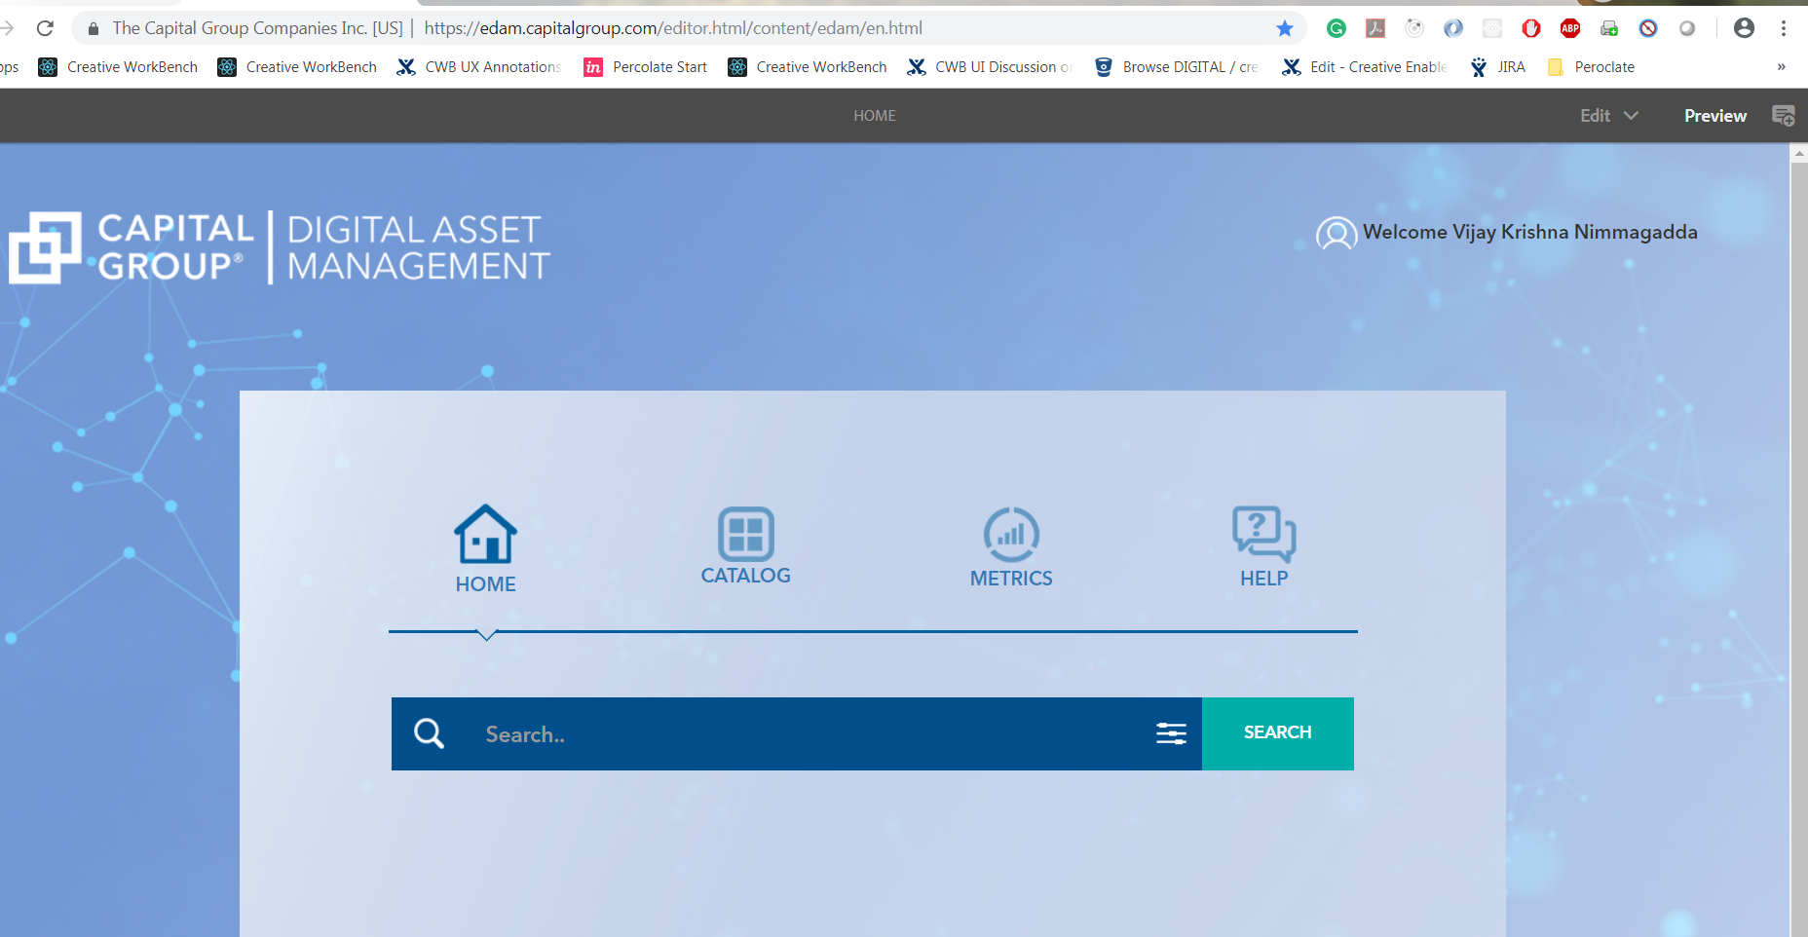

Home Page for the eDAM includes: HOME, CATALOG, METRICS, HELP

HOMEPAGE: Search Functionality includes Videos, Audio, Documents, PDF, Layouts

CATALOG: Home page: <https://edam.capitalgroup.com/editor.html/assets.html/content/dam>

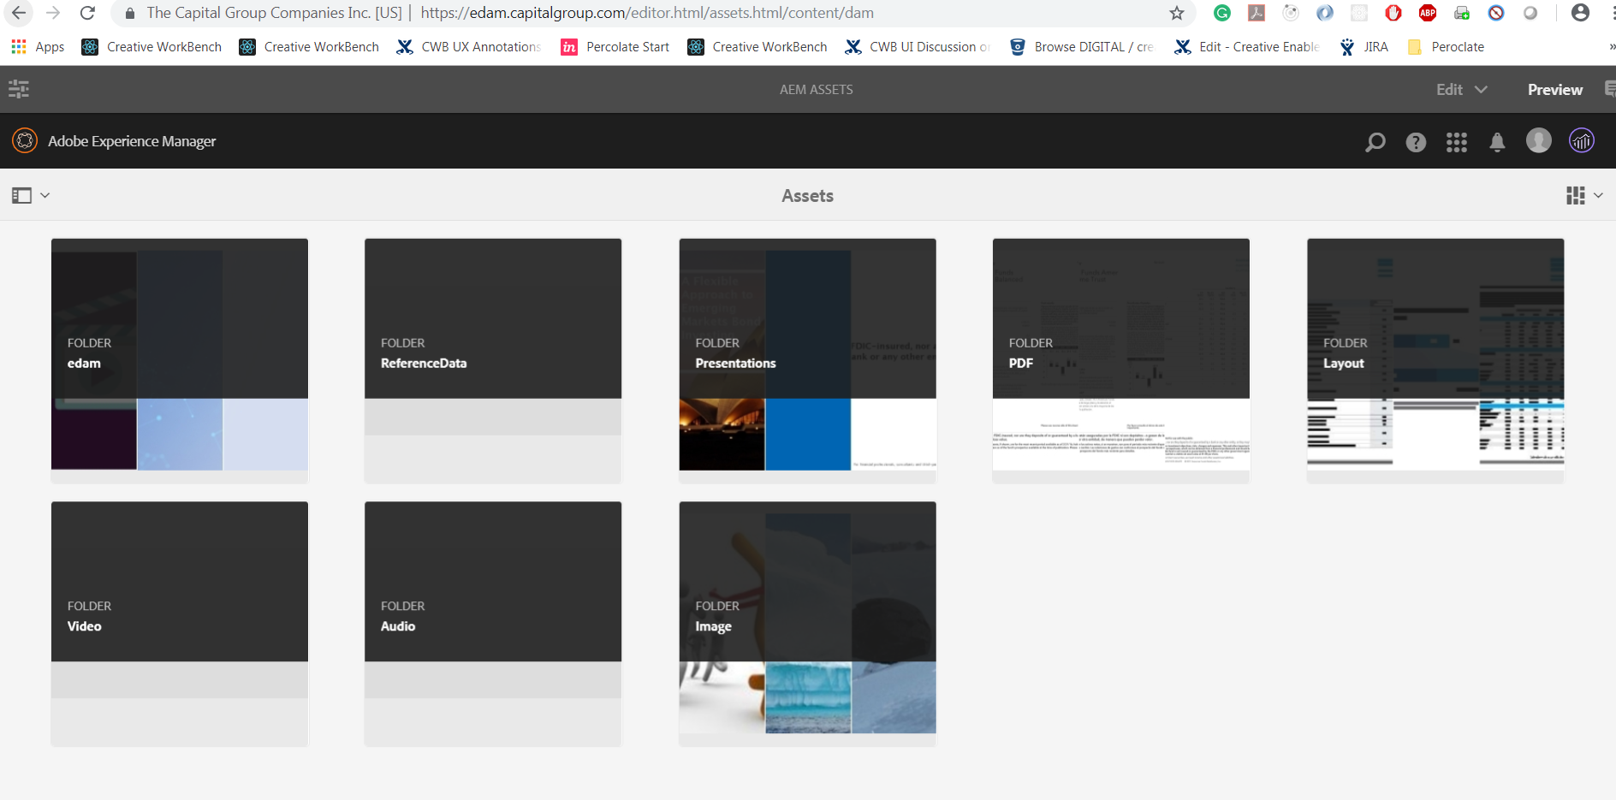

Metrics: Includes Users, Total assets, and Newly Created and Asset Details.

URL: <https://edam.capitalgroup.com/content/DAMActivity.html>

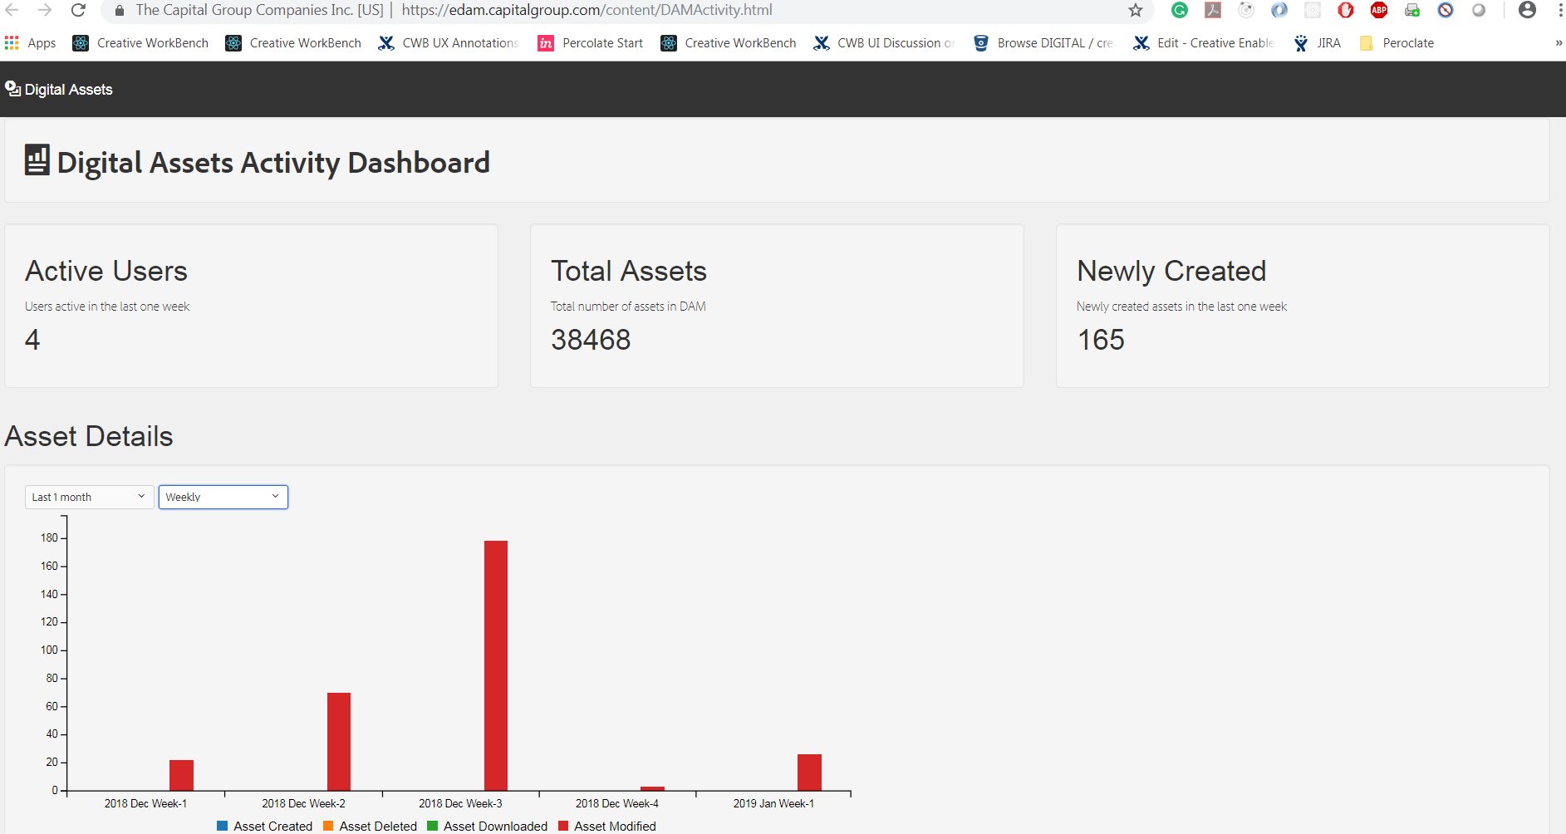

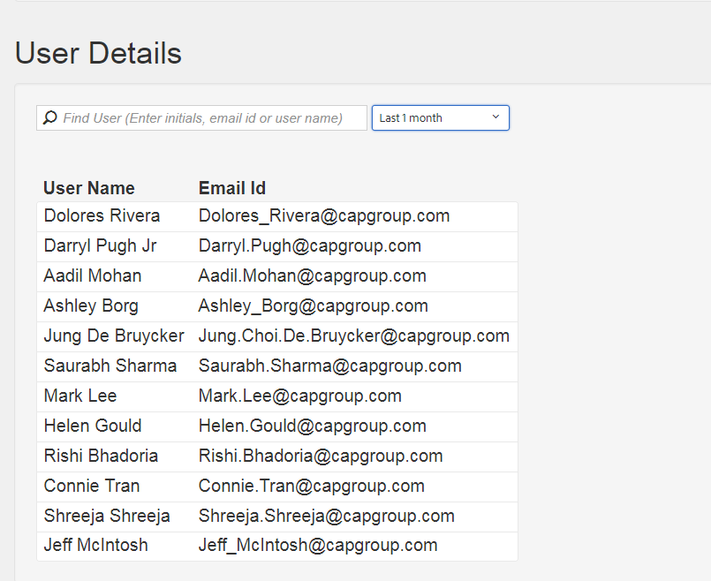

Help: Includes Customer Support, FAQ’s, Training Links, and Help Desk.

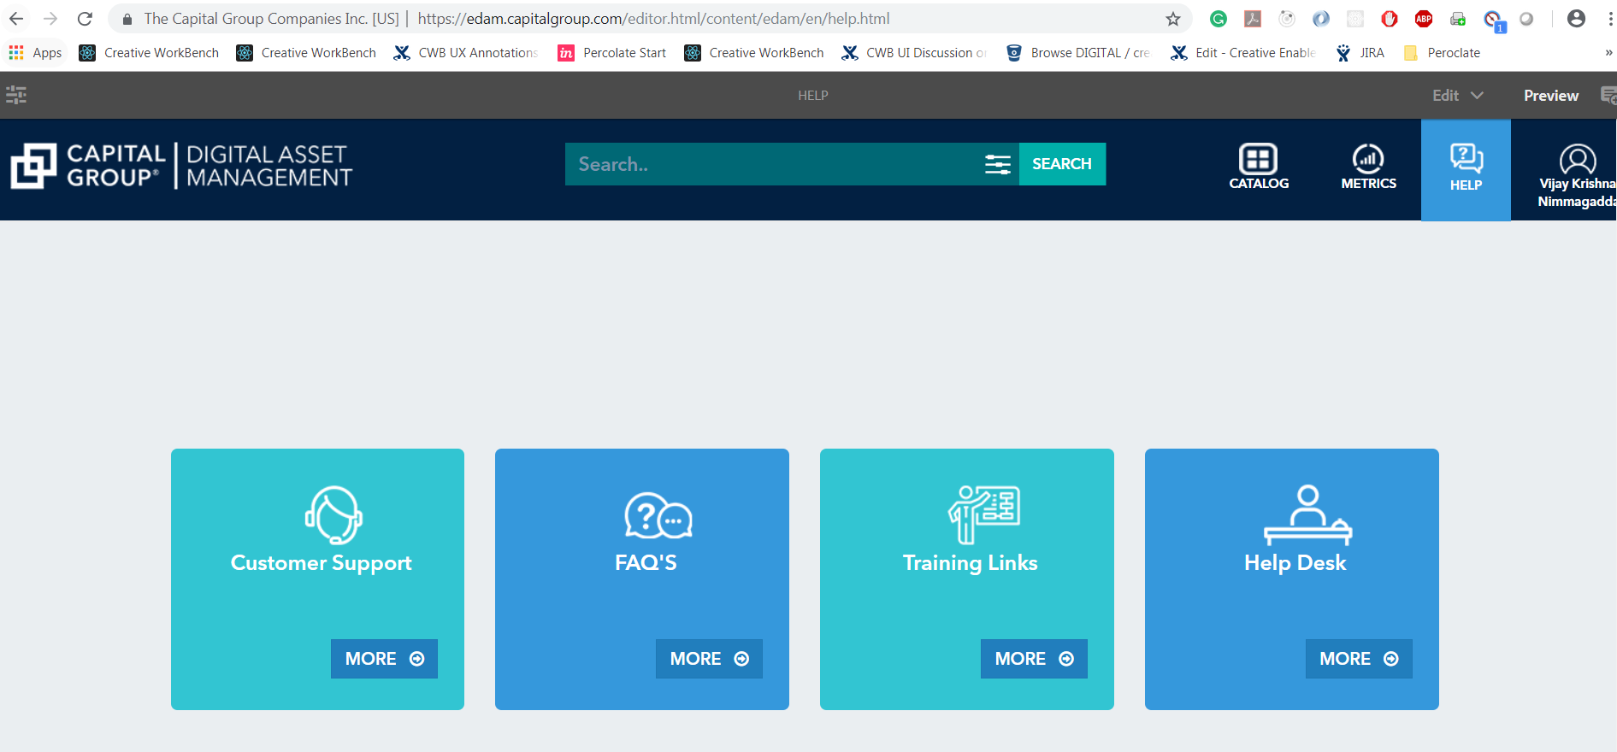

ADOBE AEM Documentation:

<https://helpx.adobe.com/support/experience-manager/6-4.html>

DAM Components include the Content and Structure.

Structure includes Homepage header, content page header

Client Library includes clientlib base, site, vendor(3rd party vendor)

Client Lib Home has different files.

AEM base stuff include codebase

Updates: Implementation done on the Help Page and Homepage.

Important Links:

1. UX Design URL:<https://confluence.capgroup.com/display/NGM/UX+DAM+-+Wire+frames+Version+2.0>
2. DAM bitbucket code: <https://bitbucket.capgroup.com/projects/DC/repos/digital-asset-management/browse>
3. Confluence Link <https://confluence.capgroup.com/pages/viewpage.action?pageId=115340372>
4. Dev URL: <https://edam.dev.capitalgroup.com/content/DAMActivity.html>
5. eDAM Metrics: <https://edam.capitalgroup.com/content/DAMActivity.html>
6. eDAM content bitbucket url: <https://bitbucket.capgroup.com/projects/DC/repos/digital-asset-management/browse/digital-assets/vault/web/apps/dam/components/content>
7. eDAM Structure bitbucket url: <https://bitbucket.capgroup.com/projects/DC/repos/digital-asset-management/browse/digital-assets/vault/web/apps/dam/components/structure>
8. AEM 4.4 documentation: <https://helpx.adobe.com/support/experience-manager/6-4.html>